Git Hands On Learning 05

Working tree clean
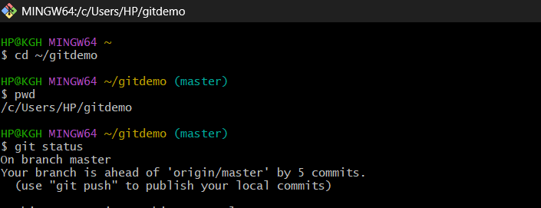

Ahead by 5 commits
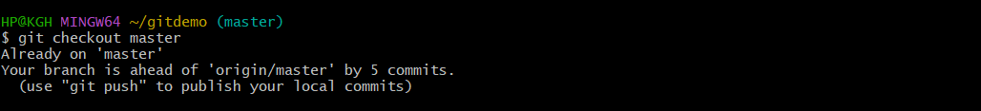

Pull: Already up to date
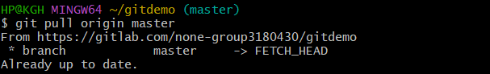

Push successful
